1. **Sử dụng danh từ, không sử dụng động từ**

**Sử dụng danh từ số nhiều**

|  |  |  |  |  |
| --- | --- | --- | --- | --- |
| **Resource** | **GET (read)** | **POST (create)** | **PUT (update)** | **DELETE (delete)** |
| /cars | Returns a list of cars | Create a new car | Bulk update of cars | Delete all cars |
| /cars/711 | Returns a specific car | Method not allowed (405) | Updates a specific car | Deletes a specific car |

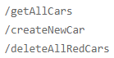

*Không sử dụng động từ*

1. **Sử dụng POST, PUT, DELETE để thay đổi trạng thái, update resource**

Không sử dụng GET để thay đổi trạng thái, update resource

1. **Sử dụng sub-resources cho các mối quan hệ**



1. **Sử dụng HATEOAS** (**H**ypermedia **a**s **t**he **E**ngine **o**f **A**pplication **S**tate)

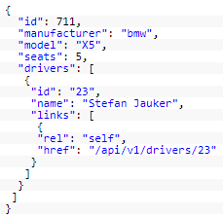

1. **Cung cấp Paging, Sorting, Filter, các field được chọn**

* Paging
  + Sử dụng page_size và page để giới hạn số record lấy ra
  + Default: page = 1, page_size = 20



* + Để gửi total record cho user thì sẽ custom HTTP header: X-Total-Count
* Sorting
  + Cho phép sort theo nhiều field



* Filter
  + Sử dụng duy nhất 1 query parameter cho tất cả các field



* Các Field được chọn

Cung cấp chọn các field sẽ làm tăng tốc độ API

VD: Mobile client chỉ hiển thị 1 vài field trong list field nên ko cần tất cả resource



Tutorial: <https://www.laurencegellert.com/2016/08/webservice-api-design-tips-correct-pagination-and-exposing-deleted-rows/>

1. **Sử dụng Version cho API**

Sử dụng số đơn giản, tránh sử dụng dấu chấm, dấu phẩy.

VD: v2.5, v1.1



1. **Handle Errors with HTTP status codes**

Nên sử dụng ít nhất 10 HTTP status code

|  |  |
| --- | --- |
| 200 – OK |  |
| 201 – OK (created) |  |
| 204 – OK (deleted) |  |
| 304 – Not Modified |  |
| 400 – Bad Request | Sai parameter |
| 401 – Unauthorized | Chưa đăng nhập |
| 403 – Forbidden | Không có quyền truy cập |
| 404 – Not found | Đường link sai |
| 422 – Unprocessable Entity |  |
| 500 – Internal Server Error | Lỗi trong server |

*Tất cả các error trả ra nên có format nhất định*

VD:

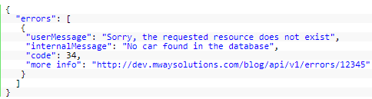

* **Reference**

<https://blog.mwaysolutions.com/2014/06/05/10-best-practices-for-better-restful-api/>

<https://docs.microsoft.com/en-us/azure/architecture/best-practices/api-design>

<https://docs.microsoft.com/en-us/azure/architecture/best-practices/api-implementation>